Project 1

**Sentimental Analysis Amazon Review System NLP**

Business Objective: Extracting sentiment from customer reviews on a product

Data Set Details:

The dataset should be scraped/extracted from ecommerce websites like amazon etc.Preferably amazon and focus only on extracting customer reviews , rest are not required

Acceptance Criterion:

Need to deploy the end results (sentiment analysis) using Rshiny/ Streamlit /Flask etc.

Group 4 :

1.Smrithi Radhakrishnan

2. ABHISHEK U B

3. Simhadri ManiShankar

4. Kavimani Reddiyar

5.Saran Prakash B

6. Kiranvel R

7. Vaishnavi K.S

8.Akshara A.S

9.Sushinth V.S

Step 1 :

We will analyze for sentimental analysis, what is sentiment analysis how its work in review process in every shoping product.

Step 2 :

Then we will download for datasets in Kaggle.

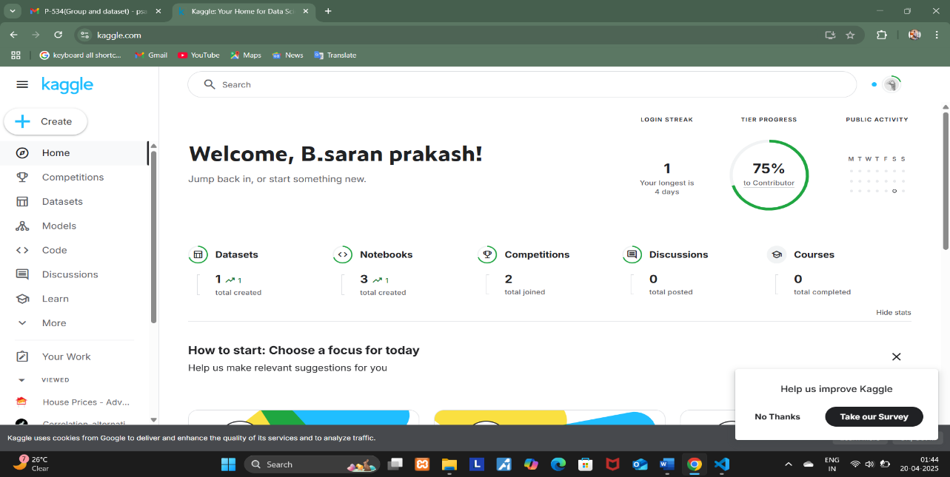

Step 3 :

Create to the python library tools like sklearn,pandas,matplotlib,numpy and textblob.

Additional import is streamlit its web application its based on python code.

Then read file for amazon_alexa.csv datasets

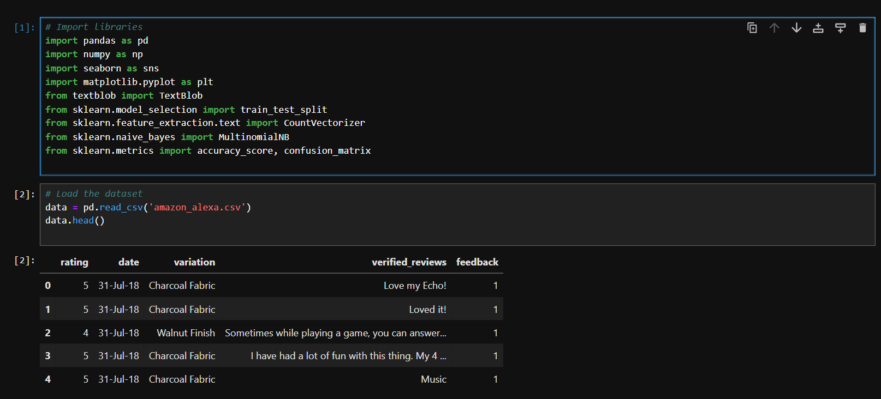

Step 4 :

After that to be create on EDA values and missing values like data Visualization

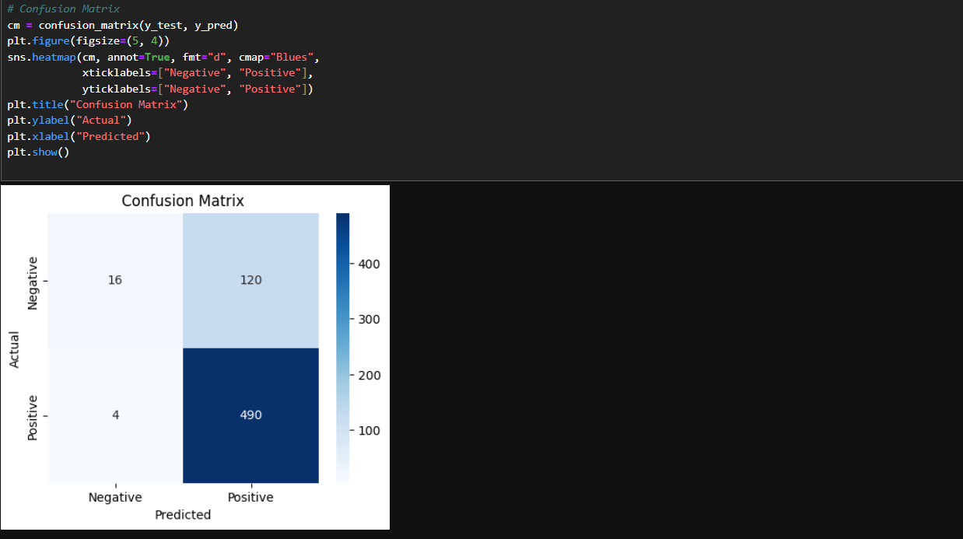

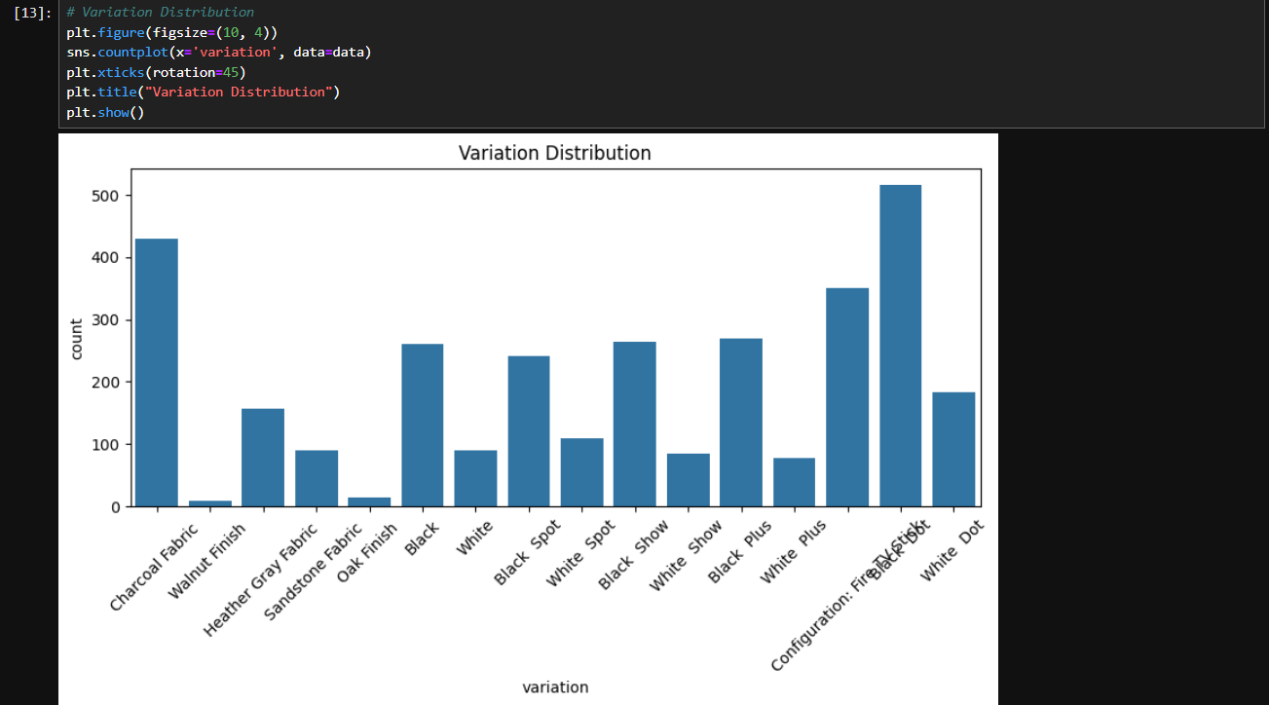

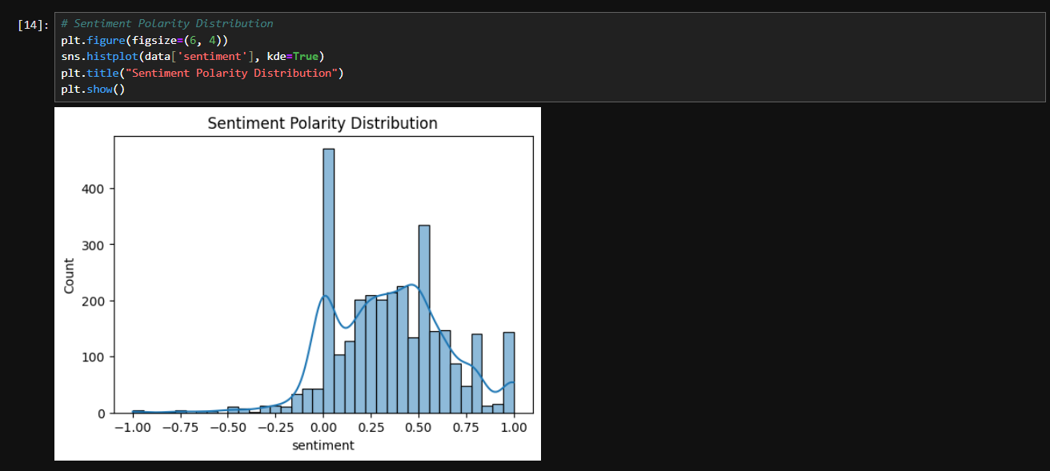

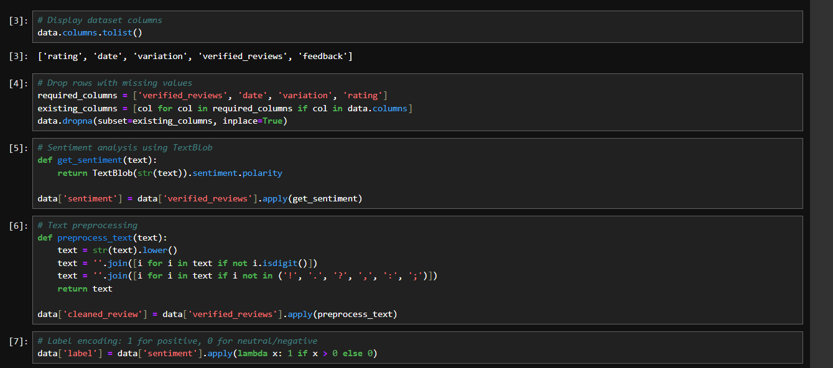

Step 5:

Machine learning algorithm used to like application based on (spam or not spam is Decision Tree Classifier,Nerual Network is face detection and anlysis its based on Deep learning).

But this project used to naïve bayes algorithm then after use to prediction value are train and test validation method. After converted into Accuracy Score and classification report .

In accuracy score more then 75% came its good datasets

75% less came its accuracy values missing that different properties.

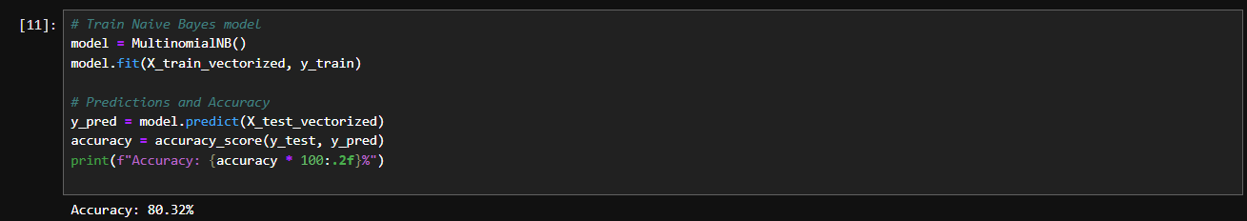

Step 6:

Textblob tools used to NLP like when they can do write reviews Amazon,Flipkart,etc

After customer and product viewer check in positive and negative command and Review.

Its will be detect to Machine learning process results.

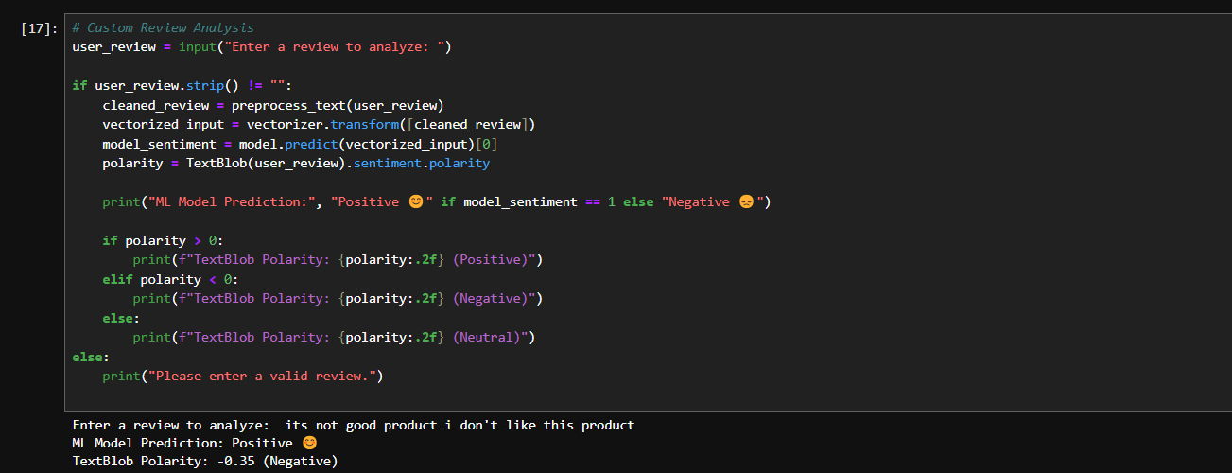

Step 7 :

Then run to project file in pycharm App.py, its will be showing on terminal-type to streamlit run App.py.

Execution like [https://docs.streamlit.io/](http://localhost:8502/)

Output Depoyed streamlit:

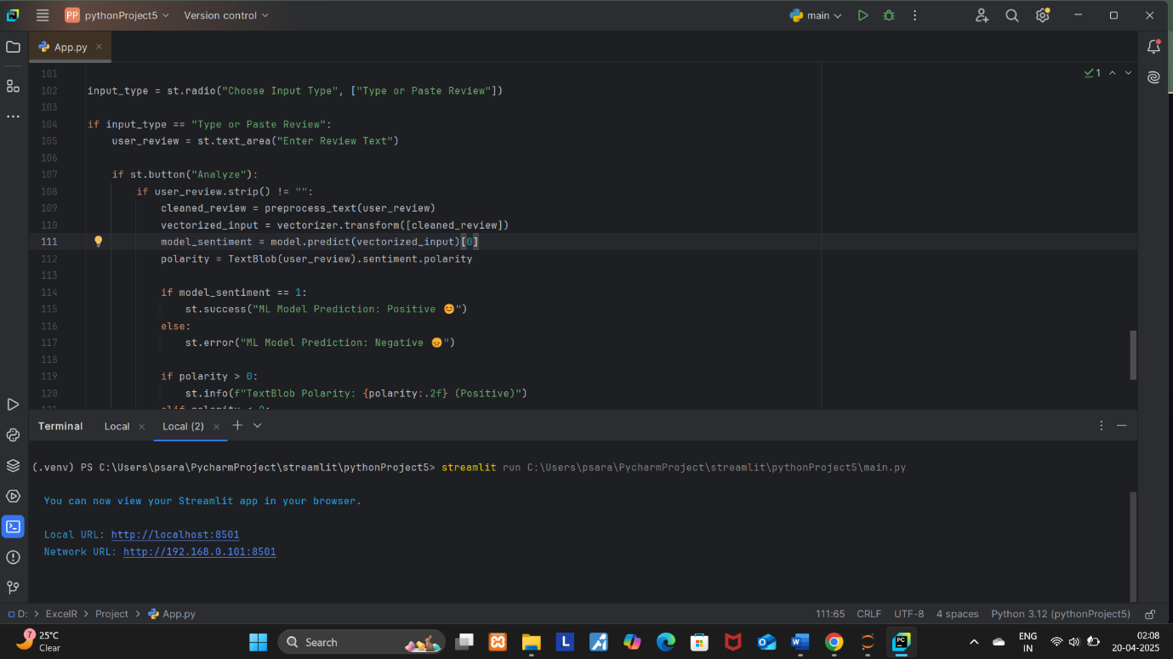

Streamlit run app.py

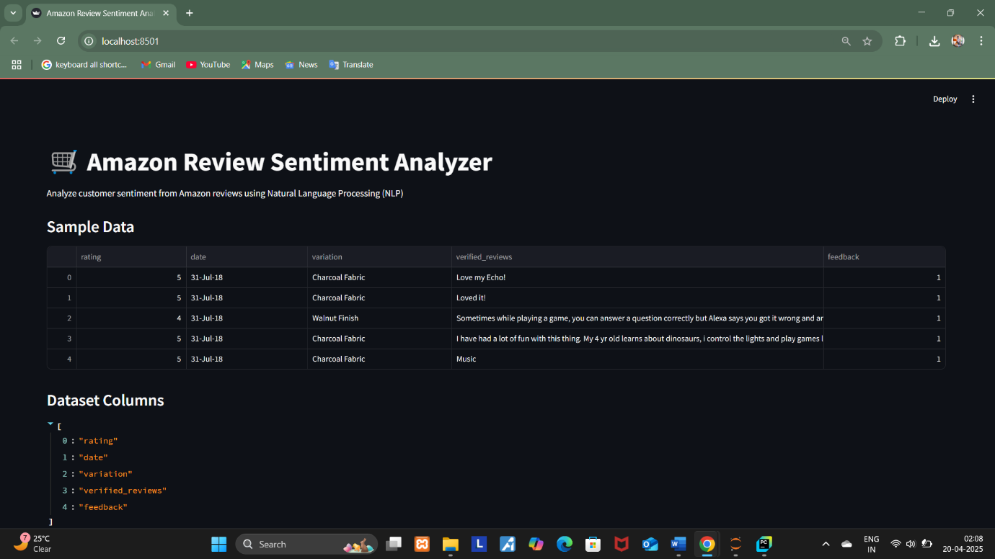

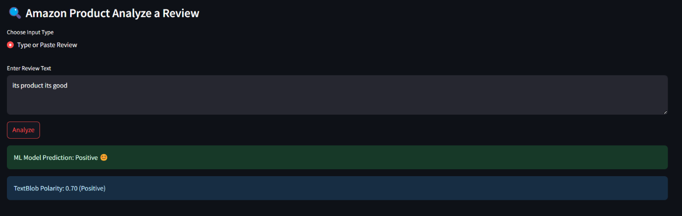

Output Video Streamlit :

